**Test Automation**

**Pre-requisites:**

1. **Docker with Jenkins & Node Js Image**
2. **Web Driver IO**
3. **Npm Packages**
4. **Git Hub**
5. **Power Shell Script**

**Steps:**

1. Create package.json file and install necessary npm packages required for preparation
2. Prepare Node.js scripts required for automation and create WDIO configuration file.

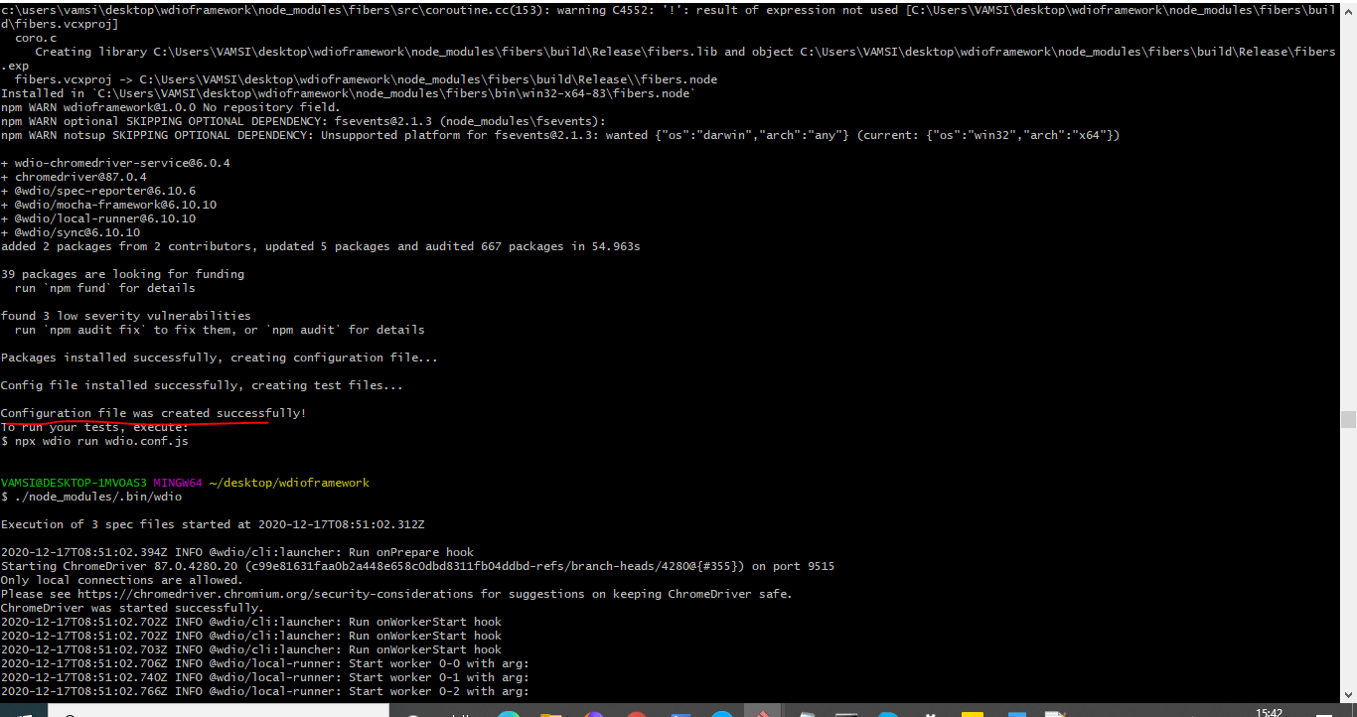

1. After it is successfully created you can see wdio.conf js file in the project directory

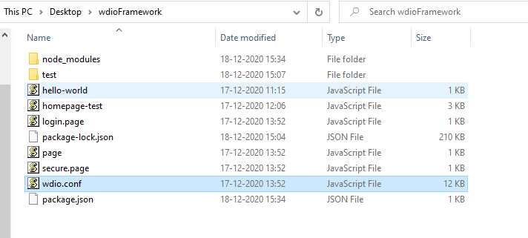

1. Design automation scripts in Node.js and save it in the project directory
2. Run the scripts with configuration file
3. Scripts should run successfully

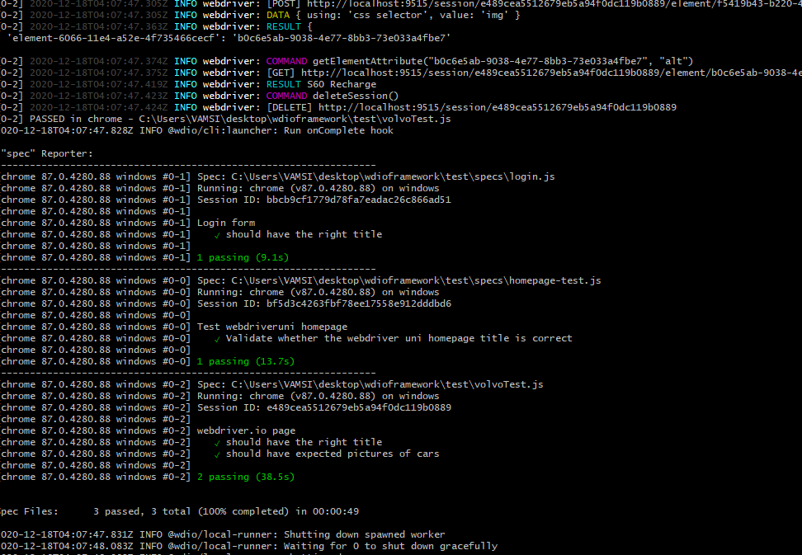

1. Now login to Shell editor and up the Docker

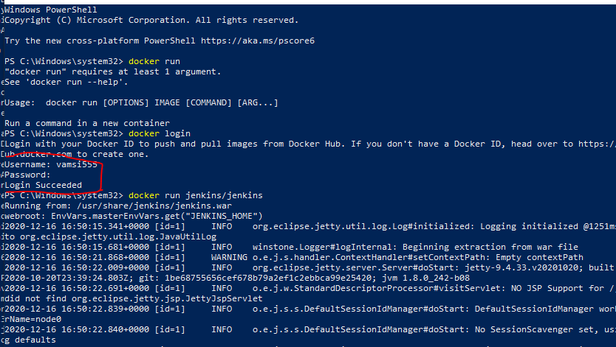

1. Create a volume in docker and persistent the Jenkins node.js image to local host machine

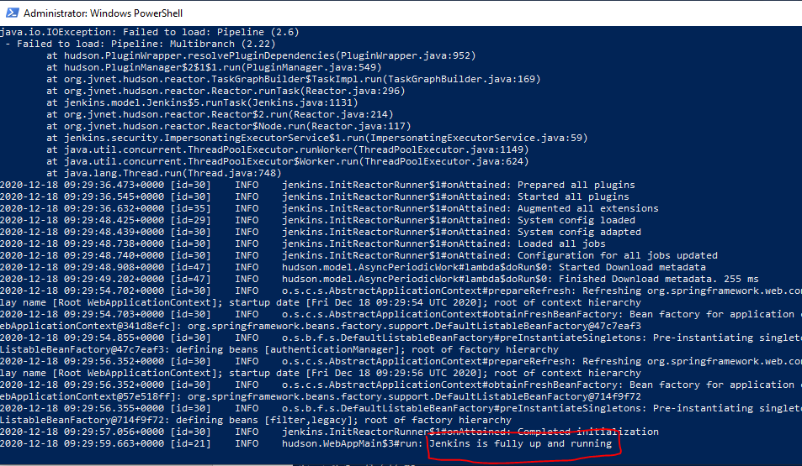

1. Login to Jenkins and install necessary plugins
2. Create a job and configure the node and npm settings and map the project path.
3. Build the job.
4. Job should run successfully and status should display in the console ouput
5. Push the code to git hub repository and commit the changes